CIS31041 - Practical for Data Mining
( Lab Sheet 04)
Reg.No:-SEU.IS.20.ICT.084 Date:-

Aim:
  - Working with Matrix
  - Working with tuples
  - Working with class
Task:
- Matrix Implementation
  - Create the matrix
  - Transform the matrix

# Creating a matrix
matrix = [
[1, 2, 3],
[4, 5, 6],
[7, 8, 9]
]

print("Original Matrix:")
for row in matrix:
print(row)

# Transforming the matrix (Transpose)
transposed_matrix = [[matrix[j][i] for j in range(len(matrix))] for i in range(len(matrix[0]))]

print("\nTransposed Matrix:")
for row in transposed_matrix:
print(row)

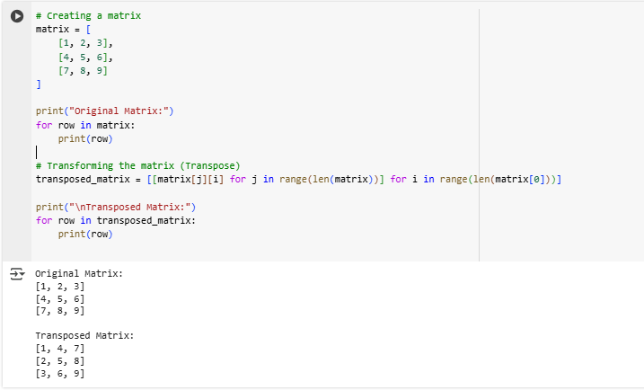
- Tuples Implementation
  - Creating a tuples
  - Create two tuples and merge together.
  - Print the elements in tuples

# a. Creating a tuple
tuple1 = (1, 2, 3, 4, 5)
print("Tuple1:", tuple1)

# b. Create two tuples and merge them together
tuple2 = ('a', 'b', 'c')
merged_tuple = tuple1 + tuple2
print("Merged Tuple:", merged_tuple)

# c. Print the elements in the tuple
print("Elements in Merged Tuple:")
for element in merged_tuple:
print(element)

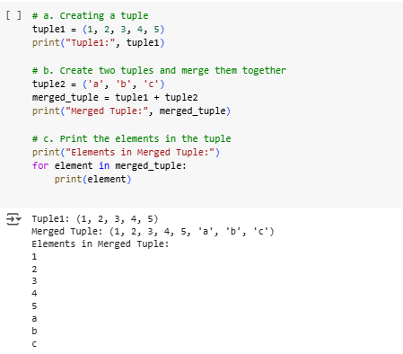

- Array
  - Defining an array
  - print the array
  - Print the last element

# a. Defining an array
array = [10, 20, 30, 40, 50]

# b. Print the array
print("Array:", array)

# c. Print the last element
print("Last element of the array:", array[-1])
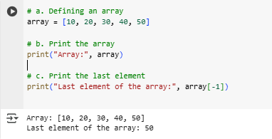

- Date functions
  - Today date
  - Birthday

import datetime

# a. Today's date
today_date = datetime.date.today()
print("Today's Date:", today_date)

# b. Birthday (Example)
birthday = datetime.date(2000, 5, 15) # Change to your actual birthday
print("Example Birthday:", birthday)

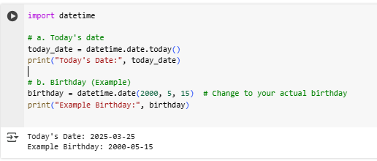

- Numpy
  - Import the numpy array as np
  - Concatenate of two arrays
  - Create the empty array
  - Creates an array of consecutive integers starting from 0 up to specified value.
  - Create the two-dimensional array
  - Sort the array
  - Find the shape, size, dimension of array
  - Reshape the array
  - Increase the dimension of array
  - Indexing and slicing
  - Create the array from existing data
  - Reshape the existing element
  - Print the array in vertical and horizontal stack
  - Split the array
  - Basic array operations
  - Summary of the array
  - Multiply the element in the array
  - Find the maximum and minimum element in the array
  - Transpose of the element

import numpy as np
print("Import NumPy as np (already done)\n")

# a. Import NumPy as np (already done)

print("a.Import NumPy as np (already done)\n")
# b. Concatenation of two arrays
arr1 = np.array([1, 2, 3])
arr2 = np.array([4, 5, 6])
concatenated_arr = np.concatenate((arr1, arr2))
print("Concatenated Array:", concatenated_arr)
print("\n")

print("c. Create an empty array\n")
# c. Create an empty array
empty_array = np.empty((2, 2))
print("Empty Array:\n", empty_array)
print("\n")

print("d. Create an array of consecutive integers starting from 0\n")
# d. Create an array of consecutive integers starting from 0
consecutive_arr = np.arange(10)
print("Array of Consecutive Integers:", consecutive_arr)
print("\n")

print("e. Create a two-dimensional array\n")
# e. Create a two-dimensional array
two_d_array = np.array([[1, 2, 3], [4, 5, 6]])
print("2D Array:\n", two_d_array)
print("\n")

print("f. Sort the array\n")
# f. Sort the array
unsorted_arr = np.array([3, 1, 4, 1, 5, 9])
sorted_arr = np.sort(unsorted_arr)
print("Sorted Array:", sorted_arr)
print("\n")

print("g. Find shape, size, dimension\n")
# g. Find shape, size, dimension
print("Shape:", two_d_array.shape)
print("Size:", two_d_array.size)
print("Dimension:", two_d_array.ndim)
print("\n")

print("h. Reshape the array\n")
# h. Reshape the array
reshaped_arr = np.reshape(consecutive_arr, (2, 5))
print("Reshaped Array:\n", reshaped_arr)
print("\n")

print("i. Increase dimension of the array\n")
# i. Increase dimension of the array
expanded_arr = np.expand_dims(arr1, axis=0)
print("Increased Dimension Shape:", expanded_arr.shape)
print("\n")

print("j. Indexing and slicing\n")
# j. Indexing and slicing
print("First element of arr1:", arr1[0])
print("Slice of arr1:", arr1[1:])
print("\n")

print("k. Create an array from existing data\n")
# k. Create an array from existing data
copied_arr = np.copy(arr1)
print("Copied Array:", copied_arr)
print("\n")

print("l. Reshape the existing array\n")
# l. Reshape the existing array
reshaped_existing = np.reshape(arr1, (3, 1))
print("Reshaped Existing Array:\n", reshaped_existing)
print("\n")

print("m. Print the array in vertical and horizontal stack\n")
# m. Print the array in vertical and horizontal stack
vstacked = np.vstack((arr1, arr2))
hstacked = np.hstack((arr1, arr2))
print("Vertical Stack:\n", vstacked)
print("Horizontal Stack:", hstacked)
print("\n")

print("n. Split the array\n")
# n. Split the array
split_arr = np.array_split(concatenated_arr, 2)
print("Split Arrays:", split_arr)
print("\n")

print("o. Basic array operations\n")
# o. Basic array operations
sum_arr = arr1 + arr2
diff_arr = arr1 - arr2
prod_arr = arr1 * arr2
print("Sum:", sum_arr)
print("Difference:", diff_arr)
print("Product:", prod_arr)
print("\n")

print("p. Summary of the array\n")
# p. Summary of the array
print("Mean:", np.mean(arr1))
print("Standard Deviation:", np.std(arr1))
print("\n")

print("q. Multiply elements in array\n")
# q. Multiply elements in array
multiplied_arr = arr1 * 2
print("Multiplied Array:", multiplied_arr)
print("\n")

print("r. Find max and min elements\n")
# r. Find max and min elements
print("Max:", np.max(arr1))
print("Min:", np.min(arr1))
print("\n")

print("s. Transpose of a 2D array\n")
# s. Transpose of a 2D array
transposed_two_d = np.transpose(two_d_array)
print("Transposed 2D Array:\n", transposed_two_d)
print("\n")

